# Spectrum Analyzer

While an oscilloscope is used to display electrical signals in an amplitude versus time format, a spectrum analyzer provides an amplitude versus frequency format. Figure 1 shows the two representations for the same signal.



Figure Oscilloscope and Spectrum Analyzer Displays

Fourier analysis shows that any complex waveform can be resolved into sinusoidal waveforms of a fundamental frequency and a number of harmonic frequencies. The spectrum analyzer effectively performs the Fourier integral:

 (1.)

The integral finds the frequency components in *s(t)* by correlating *s(t)* with cosine and sine waves at each frequency *f.*  For a particular frequency,  and



The cosine waves are in phase for all time, the product of the two cosine waves contains DC, thus the integral integrates DC over all time, resulting in infinity (delta functions) at. For all other frequencies  the cosine waves drift in and out of phase over time, there is no DC component, and the integral is zero. Thus for we can write:

 (1.)

For a digital spectrum analyzer where the signal is digitized (sampled) by an analog-to-digital converter (ADC), the Fourier transform is done using the Fast Fourier Transform (FFT) algorithm.

There is a practical upper limit to the sampling rate of an ADC. Thus analog spectrum analyzers are used for high frequencies. For an analog spectrum analyzer, frequency scanning is accomplished by electronically tuning a bandpass filter network across the desired frequency range. The amplitudes of all the signals in the bandpass area (at each point during the scan) are measured to provide the amplitude versus frequency display.

It is important to note that in order to detect two signals which are narrowly spaced, the frequency span of the bandpass filter must be set appropriately. This concept is shown in Figure 2: the frequencies f1, f2 and f3 in the input spectrum are summed into a single peak on the displayed waveform due to the excessive frequency span. Note that the DC reference shown in this figure is a characteristic of the spectrum analyzer. It is always present, regardless of whether there is a DC bias on the input signal.

Unlike an oscilloscope, the amplitude scale on a spectrum analyzer can be set to a logarithmic scale (for power measurements) as well as a linear scale (for voltage measurements). The logarithmic scale is represented in dBm, or decibels with reference to a milliwatt.

Power (dBm) = 10 log  (1.3)

It can then be shown that

Power (dBm) = 10 log  (1.4)

If the load is a standard 50Ω input

Power (dBm) = 20 log V + 10 log  = 20 log V +13 (1.5)

So the relationship between input power and input voltage is

*P*(dBm) = 20 log V + 13 (1.6)

On the linear scale, unlike a Fourier representation, the amplitudes of signals are always positive (absolute values). It is the magnitude of the signals above (in reference to) the noise level that is of interest.

The analog spectrum analyzer shows only the magnitude of each Fourier component. A digital spectrum analyzer can show phase as well as amplitude.

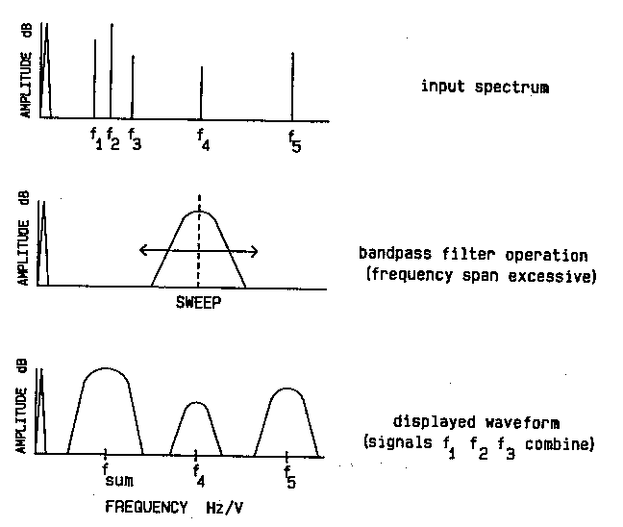

Figure Effect of Span on Spectrum Analyzer Display